Speech and Language Therapy:
Articulation Skills:

Home Practice:
- Point out words that have your child’s sound when reading a book, watching tv, or driving in the car.
- Play word games. “I am going on a picnic and I am going to bring…”. During this game, each person says something they are bringing, and everyone has to list what the people before them said, then add on their own word. When you play, you can only come up with items that have your speech sound. For example, “I am going on a picnic and I am going to bring strawberries, salad, sandwiches, snacks, etc..”.

Language Skills: 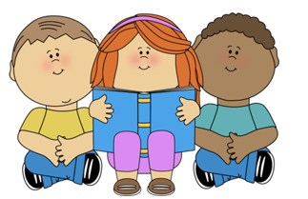
Home Practice:
- While reading books, ask your child who, what, where, when, why questions. Then, have your child ask you questions about the story.
- During your day, narrate some of the things you are doing. Children learn language most when it is modeled for them. For example, while cooking you could say: “Well, I’m going to make some scrambled eggs. First, I need to get the eggs and a bowl. Next, I’ll crack the eggs. I have to make sure I don’t get shells in the bowl…etc..”).
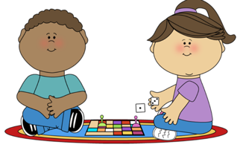 Social Skills:
Home Practice:
- While reading a story, talk about how the main character feels and why they feel that way. Also, discuss the problems in the stories and how the characters solved them. Think of other ways you would solve the problem.
- When playing a game or activity, practice turn-taking and staying on topic. Discuss the game.

