Occupational Therapy:
Fine Motor Skills: 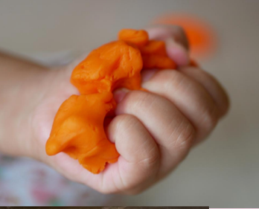
Home Practice:
- Use playdough, silly putty, or clay as an activity for squeezing, pulling, and pushing.
- Play with puzzles.
- Pick up coins and put into a piggy bank.
- Use tweezers to pick up small objects.

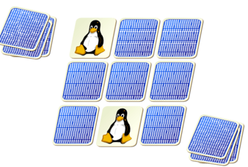 Visual Motor Skills:

Home Practice:
- Dot-to-dot worksheets.
- Playing memory games.
- Tracing letters or shapes.
- Sorting objects into categories.

Sensory Motor Skills: 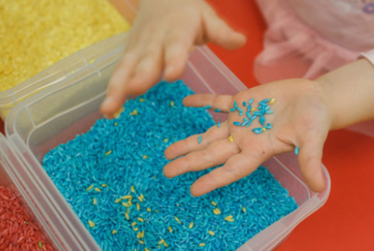

Home Practice:
- Playing with fingerpaint for exposure to new textures.
- Playing catch with a variety of different objects with different textures (ex.- stuffed animals, balloons, clothes, frisbees, etc..).
- Drawing in shaving cream or having toys like cars roll through the shaving cream.
- Sensory boxes with rice or beans and having the child reach in and find different hidden objects (ex. – toy animals, blocks, cars, etc..).

