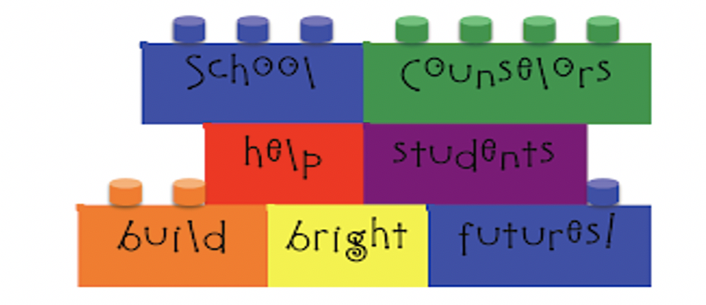

School counseling program vision:
At p.s.86 we are committed to creating an inclusive climate of trust and community. this is done through collaborations with all stakeholders involved. We pride ourselves on the relationships we invest in and build on with the students and their families and our staff. We believe students relationships are fundamental to success. When students feel supported, they’re more likely to engage in learning and have better social and academic outcomes.

My name is Barbara Korzekwinski. I am the School Counselor at P.S.86Q. I am also known as Mrs. K. I wear many hats at P.S.86Q. I can be reached at bkorzek@schools.nyc.gov .
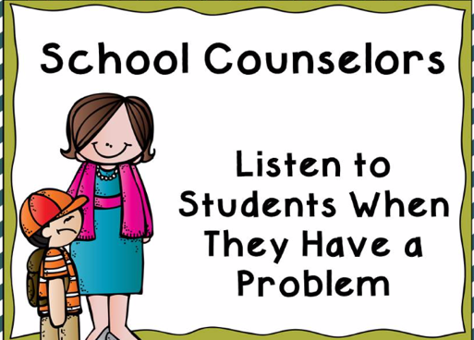

Some of my responsibilities at P.S.86Q
* At-Risk Counseling (6-8 weeks)
* Mandated Counseling: For students who have an IEP (Individual Education Plan)
* Facilitate Middle School Admissions
* Member of the schools Attendance Committee
* Member of the schools Pupil Personnel Team (PPT)
* Member of the schools Crisis Team
* Member of the schools School Implementation team (SIT)
* Designated Sexual Harassment Liaison and Respect for All Liaison which entails Investigating allegations of Bullying and Sexual Harassment.
* Students in Temporary Housing Liaison
*Suicide Prevention Liaison
*Child Abuse Designated Liaison

** What Can I Do to Keep My Child Emotionally Healthy?
https://hrl.nyc/node/hbl-behavioral-mental-health-families
** Resources for Families Child Mind Institute
https://childmind.org/audience/for-families/

Strategies:

- Headphones – block out specific frequencies.
- Weighted Vest – deep pressure.
- Cushions – for relaxing.
- Rocking Chair – for calming linear movement.

